**IDEATION PHASE PROBLEM STATEMENT**

|  |  |
| --- | --- |
| Date | 15 October 2022 |
| Team ID | PNT2022TMID47628 |
| Project Name | Real -Time Communication System Powered  by AI for Specially Abled |
| Maximum Marks | 4 Marks |

PROBLEM STATEMENT:

TITLE: Real- time communication system for specially abled person

# IDEAL SITUATION:

In the recent years, there has been rapid increase in the number of deaf and dumb victims due to birth defects, accidents and oral diseases. Since deaf and dumb people cannot communicate with normal person so they have to depend on some sort of visual communication.

The ideas consisted of designing and implement a system using artificial intelligence, image processing and data mining concepts to take input as handgestures and generate recognizable outputs in the form of text and voice with 91% accuracy.

# REALITY:

This study examines the role of Artificial Intelligence (AI) and Machine Learning in Real Time Communications. It is designed to help product, strategy, and business development decision makers communications service providers, technology vendors, communications-centric app providers, and enterprise information technology organizations.

# CONSEQUENCES:

Efficient customer communication has and continues to be at the heart of a successful business. Loyal customers define your growth trajectory. While earlier keeping them happy and satisfied used to require a large team of executives at their disposal, we are now moving towards an age where we mostly don't need to speak to someone to get our concerns resolve

# PROPOSAL:

The proposed procedure was implemented and tested with set of images. The images of single person is used for training database; the sample database is shown in fig.2.

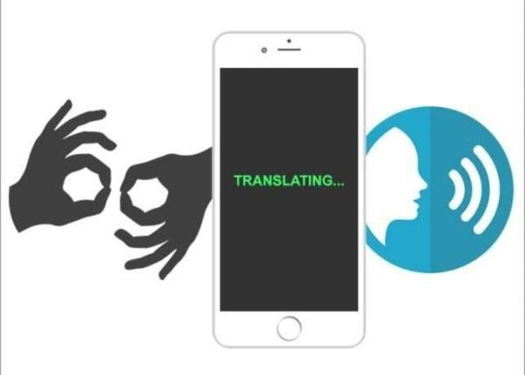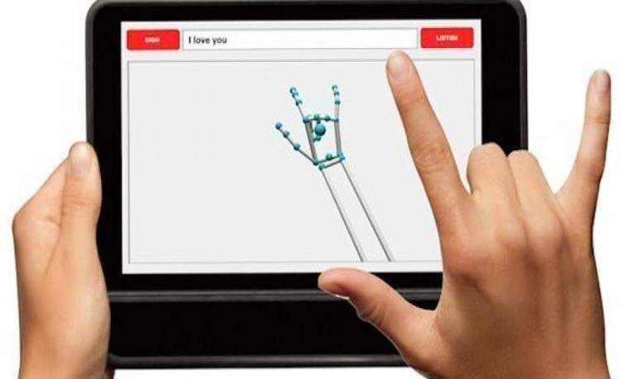

# CONCLUSION:

Sign language is a useful tool to ease the communication between the deaf person and normal person. This system converts the language in associate passing voice that's well explicable by deaf people. With this project the deaf- mute people can use the gloves to perform sign language and it will be converted into speech.